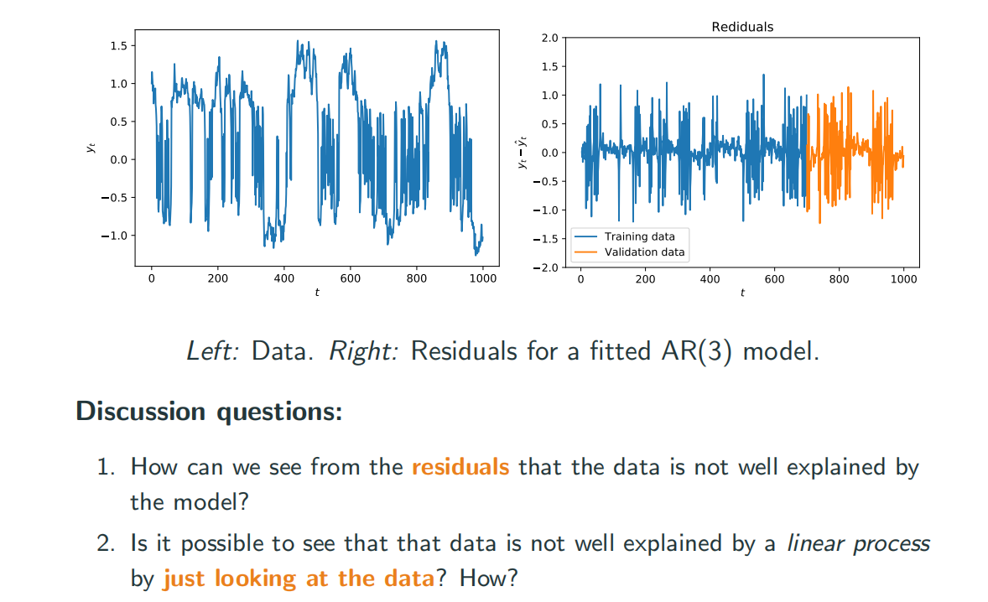

The first graph has multiple mid-center 1 0 -1,which means this model might consist of different AR models ,so the mean is not constant.

For the second one,it doesn’t have constant variance, which means it’s not a stationary sequence

The first one is non-linear. Cant tell if second one is linear or not.

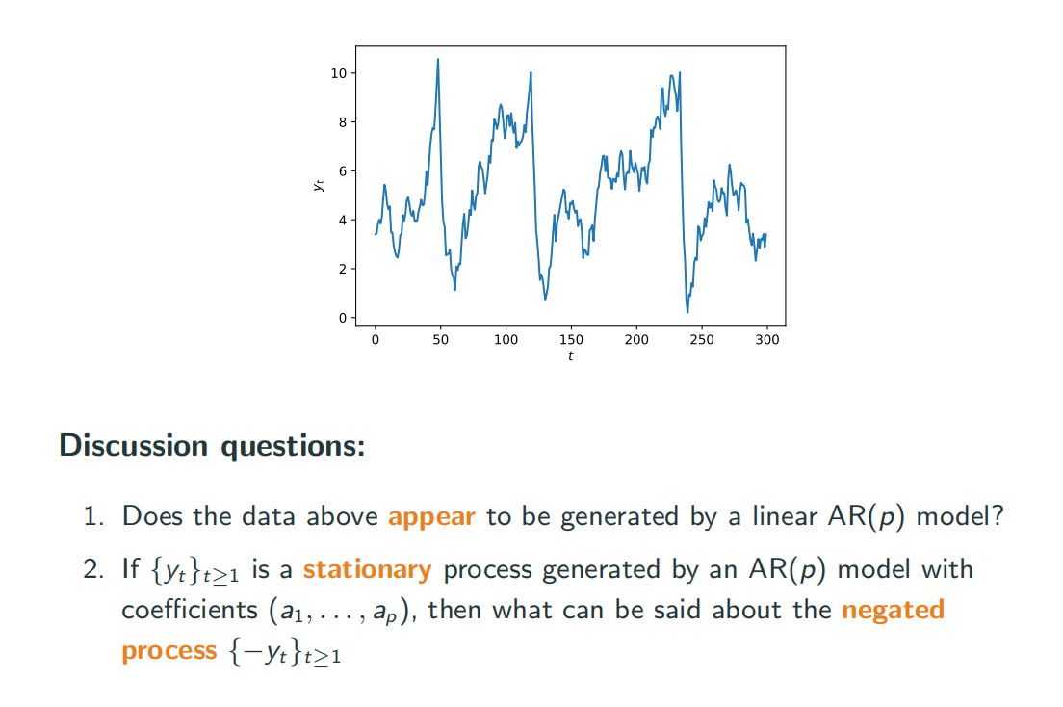

1 No, this one has changed mean value in different periods. It might consist of several AR models.

The big drop is impossible in a linear model.

2 It’s stationary . And since the mean value and variance still keep the same, the data will have same distribution as before, which means the coefficient should keep same.

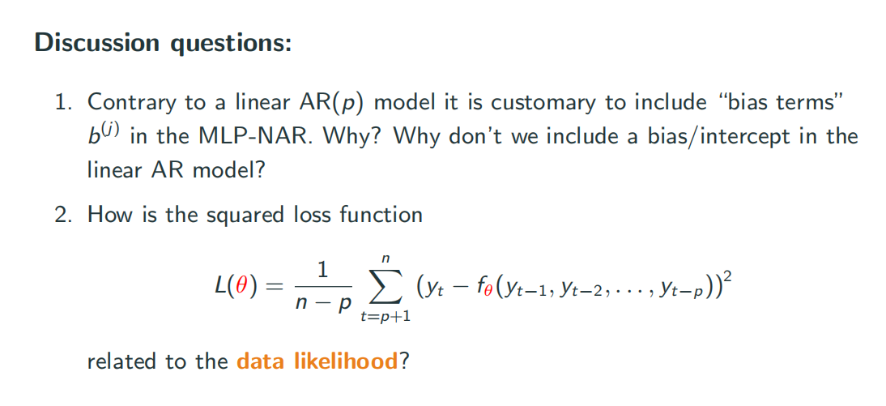

1 It’s simply because we need bias to move away from 0 when we calculating the activation function.

2 If the data is in the form of Gaussian, minimize MSE is the same as maximize likelihood. There is a relationship between loss function and likelihood

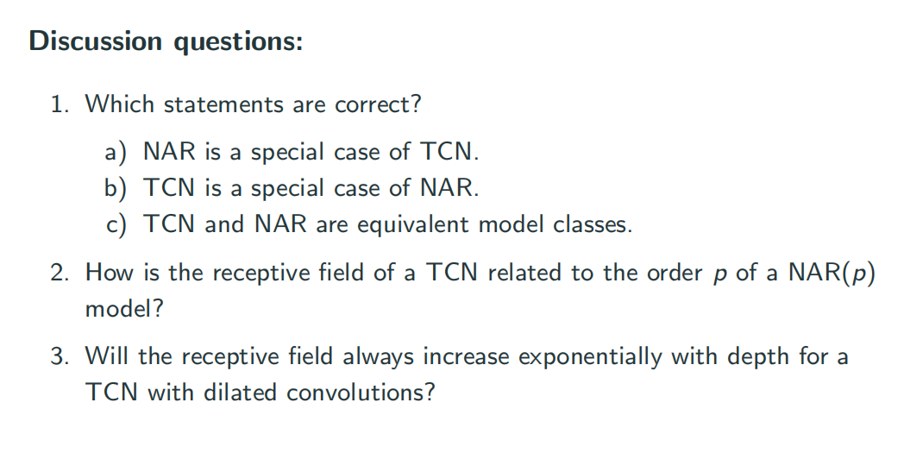

1 If we always refer to some specific previous value, then TCN cannot represent this model, but that structure is still NAR model. So TCN is a case of NAR.

2 d(p-1) +1

3 fixed dilation will result in linear increase. Increase dilation expnationaly will expionally increase receptive field